Ideation Phase
Define the Problem Statements

Date | 31 January 2026
Team ID | LTVIP2026TMIDS25024
Project Name | Visualizing Housing Market Trends: An Analysis of Sale Prices and Features using Tableau
Maximum Marks | 2 Marks

Customer Problem Statement Template:
To identify and analyse the key factors influencing housing sale prices and structural characteristics using the available housing dataset, and to transform the raw data into meaningful visual insights through Tableau dashboards and stories. This helps users understand housing market trends, renovation impact, and feature-based variations, enabling clear interpretation of housing data through interactive and structured visualizations.
Link: https://miro.com/app/board/uXjVG_M0JN0=/?share_link_id=529929348647
Reference: https://miro.com/templates/customer-problem-statement/

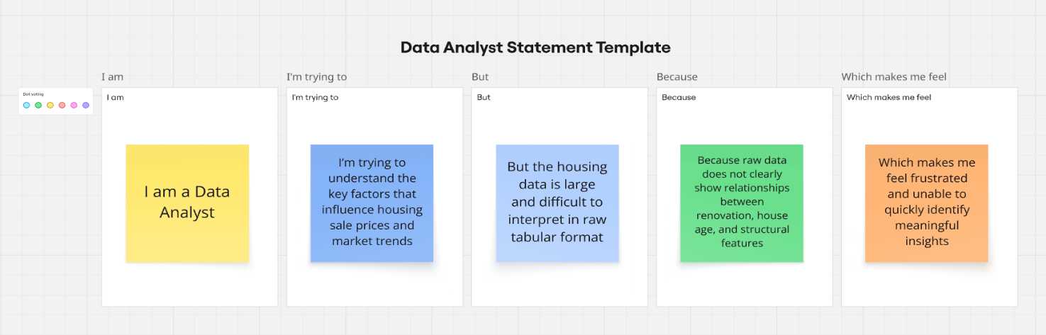

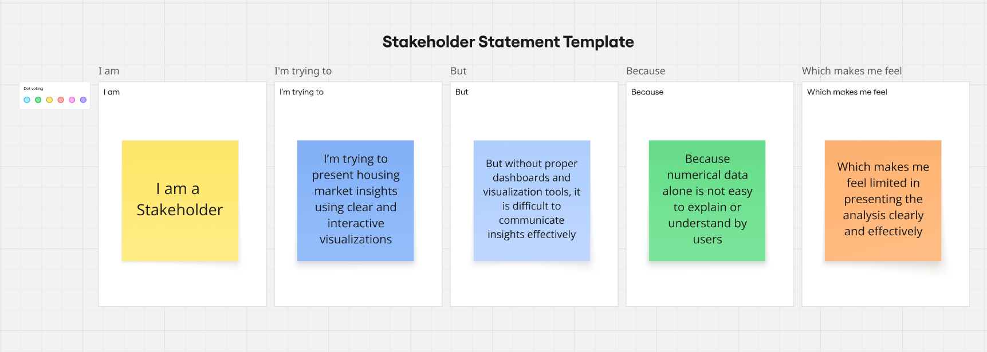

Problem Statement (PS) | I am (Customer) | I’m trying to | But | Because | Which makes me feel
PS-1 | I am a Data Analyst / Real Estate Analyst | I’m trying to understand the key factors that influence housing sale prices and market trends | But the housing data is large and difficult to interpret in raw tabular format | Because raw data does not clearly show relationships between renovation, house age, and structural features | Which makes me feel frustrated and unable to quickly identify meaningful insights
PS-2 | I am a Student / Project Developer / Stakeholder | I’m trying to present housing market insights using clear and interactive visualizations | But without proper dashboards and visualization tools, it is difficult to communicate insights effectively | Because numerical data alone is not easy to explain or understand by users | Which makes me feel limited in presenting the analysis clearly and effectively

